Metadata: Port of Albany Water Quality
Location: Port of Albany, Hudson River (42.61954 N, 73.75890 W)

Data collection period: 01/04/2011 – present

Parameters: acidity, chlorophyll*, dissolved oxygen, specific conductance,
turbidity, water temperature, water elevation**, and water velocity**.
*Chlorophyll measurements ended 12/12/2011 (see description for details)

Disclaimer: HRECOS is a research project. No warranty—either express or implied—is made for any information presented by this program.
Permission for field research at this station can be obtained through the HRECOS Coordinator
Contacts:
Brittney Flaten, HRECOS Coordinator
NY State Dept. of Environmental Conservation
265 Norrie Point Way, Staatsburg, NY 12580
Phone: 845-889-4745 x 117
Email: brittney.flaten [at] dec.ny.gov
Station description:
The Port of Albany water quality station is mounted on the concrete piling on the western shoreline of the Hudson River at the Port of Albany, just to the south of the Cargill Grainery. At mean lower-low water (MLLW), the sonde sits ~2 feet from the water surface and ~8 feet below the surface at mean higher-high water (MHHW). The channel depth at this location is 32 feet at MLLW, so the sonde sits ~30 feet from the river bottom.
All parameters are measured using a YSI 6600V2 sonde, which reports the following parameters via a CR1000 datalogger every 15 minutes: acidity, dissolved oxygen (% saturation and mg/L), specific conductance, turbidity, and water temperature (see the section titled “Sensor Specifications” for more information).
*Chlorophyll measurements ended 12/12/2011 when it was decided that data from this sensor were not informative.
**Water elevation is measured by a co-located USGS station. USGS began water velocity measurements at this site on 9/30/2016. Velocity measurements are collected using a side-looking Sontek SL500 ADCP. This data and the elevation data can also be accessed at http://waterdata.usgs.gov/nwis/uv?site_no=01359165http://waterdata.usgs.gov/ny/nwis/uv/?site_no=01355475&PARAmeter_cd=00065,00060.
Special remarks / notes:
- 11/28/2011 – Water Elevation measurements began on this date when the Water Depth sensor was surveyed to NAVD88.
- 12/12/2011 – Chlorophyll measurements ended because it was decided data from this sensor were not informative.
- Sonde deployed on 9/22/13 had a consistent offset of -0.6 deg C for the entirety of the deployment. A correction was applied to the final data for this deployment.
- 5/23/2016 – Server PC was 17 minutes slow, therefore the logger was too. Possible bad internal battery on server PC. Disabled automated time update in LoggerNet and corrected logger time (1:29 PM EST to 1:46 PM EST). Exact duration of time offset unknown, but likely less than 1 year.
- 8/2/2016 – Sonde deployment tube cleaned (using boiler brush).
- 9/30/2016 – USGS assumes responsibility for maintenance of OTT water elevation gage, and flow/current meter is added to the site. See station description for a link to the USGS data.
- 3/25/2023 – YSI 6-series sonde replaced with YSI EXO2 sonde.
Distribution terms:
HRECOS requests that attribution be given whenever HRECOS material is reproduced and re-disseminated and the HRECOS Coordinator be notified prior to publications including any part of the data. Example citation: “Hudson River Environmental Conditions Observing System. 2012. Albany Hydrologic Station data. Accessed April 13th, 2016. http://www.hrecos.org/.”
Data Quality Assurance:
Data collection and verification have been performed on all parameters (except velocity) since the establishment of this station (January 2011) according to the HRECOS Quality Assurance Project Plan, which is available at www.hrecos.org
**The level gage and velocity meter have been maintained by the U.S. Geological Survey since their adoption/installation (level and velocity, respectively) by the agency in September 2016. Water elevation is verified by USGS ~annually, while velocity is only a working dataset and is primarily purposed for short-term operational use. USGS-verified data may have been corrected based on field measurements, sensor calibrations, sensor cleanings, and other observations using standard USGS methodology. Unverified data is provisional and is subject to revision.
QAQC Comment Code definitions:
General Errors
[GIM] instrument malfunction
[GIT] instrument recording error, recovered telemetry data
[GMC] no instrument deployed due to maintenance/calibration
[GPF] power failure/low battery
[GQR] rejected due to QAQC checks
[GSM] see metadata
[GIC] no instrument deployed due to ice
[GNF] deployment tube clogged/no flow
[GOW] out of water event
Sensor Errors
[SBO] blocked optic
[STF] catastrophic temperature sensor failure
[SCF] conductivity sensor failure
[SDF] depth port frozen
[SDP] DO membrane puncture
[SDO] DO suspect
[SIC] incorrect calibration/contaminated standard
[SNV] negative value
[SPC] post calibration out of range
[SSD] sensor drift
[SSM] sensor malfunction
[SOW] sensor out of water
[SSR] sensor removed (not deployed)
[STS] turbidity spike
[SWM] wiper malfunction/loss
Comments
(CAB) algal bloom
(CAF) acceptable calibration/accuracy error of sensor
(CAP) depth sensor in water, affected by atmospheric pressure
(CBF) biofouling
(CCU) cause unknown
(CDA) DO hypoxia < 28 percent saturation
(CDB) disturbed bottom
(CDF) data appear to fit conditions
(CFK) fish kill
(CIP) surface ice present at sample station
(CLT) low tide
(CMC) in field maintenance/cleaning
(CMD) mud in probe guard
(CND) new deployment begins
(CRE) significant rain event
(CSM) see metadata
(CTS) turbidity spike
(CVT) possible vandalism/tampering
(CWD) data collected at wrong depth
(CWE) significant weather event

Parameter | Units | Sensor type | Model | Range | Accuracy | Resolution | Other
Acidity | Hydrogen ion concentration (pH) | Glass combination electrode | YSI 6589 Fast-response pH Sensor | 0 – 14 units | ±0.2 units | 0.01 units | NA
Specific Conductance | Microsiemens per cm (µS/cm) | Nickel electrode | YSI 6560 | 0 – 100 µS/cm | ±-0.5% + 0.001 µS/cm | 0.001 – 0.1 µS/cm (range dependent) | NA
Dissolved oxygen | Air saturation (%)  ⎯⎯⎯⎯  mg/L | Optical  ⎯⎯⎯⎯  Calculated | YSI 6150 ROX | 0 – 500%  ⎯⎯⎯⎯  0 – 50 mg/L | 0 – 200%: ±1%  200 – 500%: ±15%  ⎯⎯⎯⎯  0 – 20 mg/L: ±-0.1 mg/L or 1% (whichever is greater);  20 – 50 mg/L: ±-15% | 0.1%  ⎯⎯⎯⎯  0.01 mg/L | NA
Turbidity | Nephelometric Turbidity Units (NTU) | Optical | YSI 6136 | 0 – 1000 NTU | ±2% or 0.3 NTU (whichever is greater) | 0.1 NTU | NA
Water temperature | Celsius (°C) | Thermistor | YSI 6560 | -5 – 45 °C | ±0.15 °C | 0.01 °C | NA
Table 1. YSI 6600 sonde sensor specifications. Equipment was upgraded on 3/25/2023.

Parameter | Units | Sensor type | Model | Range | Accuracy | Resolution | Other
Acidity | Hydrogen ion concentration (pH) | Glass combination electrode | EXO2 - 599702 | 0 – 14 units | ±0.1 pH units within ±10˚C of calibration temp; ±0.2 pH units for entire temp range | 0.01 units | NA
Conductivity | Microsiemens per cm (µS/cm) | 4-electrode cell with auto ranging | EXO2 - 599870-01 | 0 – 200 µS/cm | 0 to 100: ±0.5% of reading or 0.001 mS/cm, whichever is greater.; 100 to 200: ±1% of reading | 0.0001 – 0.01 µS/cm (range dependent) | NA
Dissolved oxygen | Air saturation (%)  ⎯⎯⎯⎯  mg/L | Optical  ⎯⎯⎯⎯  Calculated | EXO2 - 599199-01 | 0 – 500%  ⎯⎯⎯⎯  0 – 50 mg/L | 0 – 200%: ±1%  200 – 500%: ±5%  ⎯⎯⎯⎯  0 – 20 mg/L: ±-0.1 mg/L or 1% (whichever is greater);  20 – 50 mg/L: ±5% | 0.1%  ⎯⎯⎯⎯  0.01 mg/L | NA
Turbidity | Formazin Nephelometric Units (FNU) | Optical | EXO2 - 599101-01 | 0 – 4000 NTU | 0 to 999: 0.3 or ±2% of reading, whichever is greater.; 1000 to 4000: ±5% of reading | 0 to 999 = 0.01; 1000 to 4000 = 0.1 | NA
Water level | Meters (m) | Pressure Transducer | Integral in EXO2 sonde | 0 – 10 m | 0 – 15 ft: ±0.01 ft (0.003 m);  15 – 35 ft: ±0.065%;  35 – 50 ft (0.006 m) | Max. traceable rate of change: 3 ft/minute | Non-vented
Water temperature | Celsius (°C) | Thermistor | EXO2 - 599870-01 | -5 to 35 °C | ±0.04% FS (±0.004 m or ±0.013 ft) | 0.001 °C | NA
Table 2. YSI EXO2 sensor specifications. Equipment was upgraded on 3/25/2023.

Appendix A:
Characterizing cross-channel variability at the Albany HRECOS site.
Prepared by:
Stuart Findlay
Cary Institute of Ecosystem Studies
Millbrook, NY

Transmitted to Alene Onion, HRECOS Coordinator on Jan 8, 2011

In late November 2010, in accordance with established procedures to determine the representativeness of near shore sites in the HRECOS network, field sampling was conducted in Albany at the location of the proposed new HRECOS site (42 37 10.42;73 45 32.09). On November 30, 2010 a YSI Sonde was deployed on the west shore at the planned HRECOS location and a sampling transect was laid out perpendicular to the shore. The shore sonde recorded every 15 minutes and was left in place for 4 days but only the first few hours are reported here for comparison with observations from the main channel transects. Three locations along the transect (West, Middle and East) were sampled for suspended sediment and chlorophyll four times at approximately hourly intervals with duplicate 1 L samples collected at 1, 5 and 10 m depth. A YSI sonde was attached to the line holding the intake tube for the water samples thus providing a parallel set of water quality observations. Transect sampling took place during an ebbing tide to detect any spatial patterns due to upstream effects.
An ISCO sampler was also deployed at the HRECOS site but samples were contaminated by what we presume was overwash by a large boat wake.

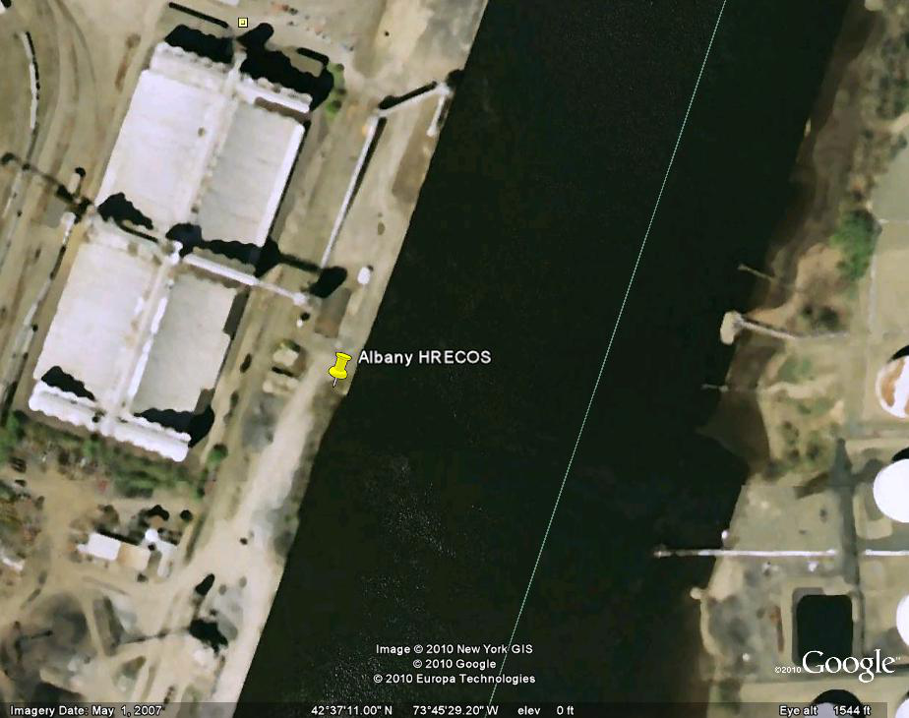

All water samples were analyzed for suspended matter and chlorophyll using established protocols. The YSI sondes were calibrated and checked using established protocols.

RESULTS:
The cross-channel characterization took place during a relatively low flow and low turbidity period but immediately preceding a heavy rain event. Suspended matter showed little variability across the channel with all values less than 4 mg dry mass/L (Fig. 1). These concentrations are low compared to the river-wide mean of 11 mg DM/L but probably not abnormal for this reach. Concentrations were higher at depth for the middle and eastern sites but the actual range of variability was very small. Turbidity measured during the transect sampling showed very little variation either across the channel or with depth and all means were between 2 and 3 NTU (data not shown, full data file appended). Turbidity measured across the transects was very close to the mean value observed during the same time interval at the proposed HRECOS site (Table 1).
Chlorophyll concentrations in water samples collected across the transect showed no horizontal or vertical variability (data not shown) with an overall mean concentration of 0.7 ug Chl/L. Chlorophyll values recorded by the sonde across all transect locations averaged 1.7 ug Chl/L with a range from 1 to 2.8 ug/L (data not shown).

Fig. 1. Mean values for total seston at the western (closest to HRECOS site), middle and eastern transect sampling locations showing variability among sampling depths (1, 5 and 10 m).
Dissolved oxygen showed little variation across the transect sampling sites but a clear (although tiny) decrease in oxygen at deeper depths (Fig. 2). Values at the shore (HRECOS) site were very close to the mean value found for the transect sites (Table 1). All DO values were slightly above saturation expected for ambient water temperatures (~ 4 C).
Conductivity showed no variation either across the transects or with depth (data not shown) and all values were within a few percentage points. Mean conductivity determined at the Shore site was indistinguishable from the mean of the transect samples (Table 1).

Table 1: Comparison of shore (HRECOS) site and transect sites for DO, turbidity and conductivity. Shore values are the means of readings from 1330 to 1545 to span the same time interval as transect sampling. Transect values are the means of all locations and depths

 | Shore Mean | Shore SD (n) | Transect Mean | Transect SD (n)
DO (mg/L) | 13.7 | 0.03 (12) | 14.2 | 0.05 (54)
Turbidity (NTU) | 2.32 | 0.04 (12) | 2.44 | 0.65 (54)
Conductivity (mS) | 0.206 | 0.002 (12) | 0.202 | 0.003 (54)

Fig. 2: Mean values for dissolved oxygen at the western (closest to HRECOS site), middle and eastern transect sampling locations showing variability among sampling depths (1, 5 and 10 m).

CONCLUSIONS:
Based on the fall sampling, the proposed western shore location for a HRECOS water quality site will adequately represent conditions in the main channel. Under conditions of this sampling solutes (conductivity and DO) were well-mixed across the channel with only minor variation in DO with depth. Under different conditions when various point sources in the Albany pool might be a greater contribution to loading or when ambient DO is at lower equilibrium values it is not unreasonable to expect different patterns in spatial variability.
Turbidity and suspended matter did not parallel each other which is not unexpected given the very small range observed for both variables. Moreover, there is no particular reason to expect a relationship between light-scattering and total particle mass although across a wide enough range (> 10-fold) there is often a weak pattern. Comparing the turbidity values at the West shore with the other sampled locations shows that the proposed HRECOS site adequately represents the mean turbidity in the channel under these conditions. The direct measurements of chlorophyll are close to values reported by the sondes but it is worth keeping in mind that the levels are quite low and there was no range in either set of observations.

