Metadata: Mohawk River Lock 8 Water Quality Station

Location: Lock 8, Mohawk River (42.8281 N, 73.9904 W)

Data collection period: 01/04/2012– present

Parameters: acidity, dissolved oxygen, specific conductance, turbidity, water elevation*, and water temperature

*Water elevation is measured by USGS using a co-located OTT Compact Bubbler System.
Disclaimer: HRECOS is a research project. No warranty—either express or implied—is made for any information presented by this program.
Contacts:
Brittney Flaten, HRECOS Coordinator and Station Manager
NY State Dept. of Environmental Conservation 256 Norrie Point Way, Staatsburg NY 12580 Phone: 845-889-4745
Email: brittney.flaten [at] dec.ny.gov
Station details:
The hydrologic station for Mohawk Lock 8 is at the downstream end of the sheet piling below Lock 8 on the Mohawk River/Erie Canal. Sensors are approximately 5 ft. above the riverbed.
Water quality parameters are measured using a YSI 6600V2 sonde. The sonde reports the following parameters every 15 minutes: acidity, dissolved oxygen (% saturation and mg/L), specific conductance, turbidity, and water temperature (see the section titled “Sensor Specifications” for more information). Data is logged to a Campbell Scientific CR1000 datalogger, and is transmitted hourly to the HRECOS database via FTP.
*Water elevation is measured by USGS using a co-located OTT Compact Bubbler System. Water level is converted from NGVD29 to NAVD88 relative to sea level (USGS gage height + 200 ft. – 0.538 ft.). Only 15-minute data is retained for HRECOS, but the gage records at 5-minute intervals. Original USGS data can be accessed at the following URL: http://waterdata.usgs.gov/usa/nwis/uv?01354330.
Distribution terms:
HRECOS requests that attribution be given whenever HRECOS material is reproduced and re-disseminated and the HRECOS Coordinator be notified prior to publications including any part of the data. Example citation: “Hudson River Environmental Conditions Observing System. 2012. Lock 8 Hydrologic Station data. Accessed April 13th, 2016. http://www.hrecos.org/.”
Data Quality Assurance:
Data collection and verification have been performed since the establishment of this station (January 2012) according to the HRECOS Quality Assurance Project Plan, which is available at www.hrecos.org See relevant section on following pages for QAQC flag and comment code definitions.
*The level gage is maintained by the U.S. Geological Survey. Data QAQC for this parameter occurs on a different

schedule than the sonde parameters (~annually, as opposed to quarterly). Verified data may have been corrected based on field measurements, sensor calibrations, sensor cleanings, and other observations using standard USGS methodology. Unverified data is provisional and subject to revision.
Special notes:
- 1/22/14 07:00 – 2/27/14 07:45: OTT bubbler orifice was frozen. YSI depth sensor (with atmospheric pressure correction applied) was activated and OTT data stream was replaced for this time period.
- 12/4/13 16:00 to 4/24/14 11:15: Sonde deployed on 12/4/13 appears to have a consistent temperature offset of ~-0.75 deg C for the entirety of the deployment. A correction of +0.75 deg C was applied to water temperature. As a result of temperature dependence by DO and pH measurements, this offset introduces a small amount of error to concurrent records of these parameters.
- (Same period as above): Significant, but gradual pH drift occurred. All pH records in the period are marked as suspicious.
- 12/10/14 – Sonde deployed had negative temperature offset similarly to last year (albeit different sonde was deployed). Data was corrected with a +0.67 deg C offset and probe replaced after deployment.
QAQC Comment Code definitions:
General Errors
[GIM] instrument malfunction
[GIT] instrument recording error, recovered telemetry data [GMC] no instrument deployed due to maintenance/calibration [GPF] power failure/low battery
[GQR] rejected due to QAQC checks [GSM] see metadata
[GIC] no instrument deployed due to ice [GNF] deployment tube clogged/no flow [GOW] out of water event
Sensor Errors
[SBO] blocked optic
[STF] catastrophic temperature sensor failure [SCF] conductivity sensor failure
[SDF] depth port frozen
[SDP] DO membrane puncture [SDO] DO suspect
[SIC] incorrect calibration/contaminated standard [SNV] negative value
[SPC] post calibration out of range [SSD] sensor drift
[SSM] sensor malfunction [SOW] sensor out of water
[SSR] sensor removed (not deployed) [STS] turbidity spike
[SWM] wiper malfunction/loss Comments
(CAB) algal bloom

(CAF) acceptable calibration/accuracy error of sensor
(CAP) depth sensor in water, affected by atmospheric pressure (CBF) biofouling
(CCU) cause unknown
(CDA) DO hypoxia < 28 percent saturation (CDB) disturbed bottom
(CDF) data appear to fit conditions (CFK) fish kill
(CIP) surface ice present at sample station (CLT) low tide
(CMC) in field maintenance/cleaning (CMD) mud in probe guard
(CND) new deployment begins (CRE) significant rain event (CSM) see metadata
(CTS) turbidity spike
(CVT) possible vandalism/tampering (CWD) data collected at wrong depth (CWE) significant weather event

Last updated: 12/15/23
Table 1. YSI 6600-series sensor specifications.

Parameter | Units | Sensor type | Model | Range | Accuracy | Resolution | Other
Conductivity | Microsiemens per cm (µS/cm) | Nickel electrode | YSI 6560 | 0 – 100  µS/cm | ±-0.5% + 0.001 µS/cm | 0.001 – 0.1  µS/cm (range dependent) | NA
Dissolved oxygen | Air saturation (%)  ⎯⎯⎯⎯  mg/L | Optical  ⎯⎯⎯⎯  Calculated | YSI 6150 ROX | 0 – 500%  ⎯⎯⎯⎯  0 – 50 mg/L | 0 – 200%: ±1%  200 – 500%: ±15%  ⎯⎯⎯⎯  0 – 20 mg/L: ±-0.1 mg/L or 1% (whichever is greater);  20 – 50 mg/L: ±-15% | 0.1%  ⎯⎯⎯⎯  0.01 mg/L | NA
Water  temperature | Celsius (°C) | Thermistor | YSI 6560 | -5 – 45 °C | ±0.15 °C | 0.01 °C | NA
Acidity | Hydrogen ion concentration  (pH) | Glass combination  electrode | YSI 6589 Fast-  response pH  Sensor | 0 – 14 units | ±0.2 units | 0.01 units | NA
Turbidity | Nephelometric  Turbidity Units (NTU) | Optical | YSI 6136 | 0 – 1000  NTU | ±2% or 0.3 NTU (whichever is greater) | 0.1 NTU | NA
Water level | Meters/Feet | Nitrogen bubbler | OTT Bubbler Sensor | 0 – 50 ft  (15.24 m) | 0 – 15 ft: ±0.01 ft (0.003 m);  15 – 35 ft: ±0.065%;  35 – 50 ft (0.006 m) | Max. traceable rate of change: 3 ft/minute | Vented to atmosphere
Water level (sonde;  backup) | Meters (m) | Strain gauge pressure  transducer | YSI 6600V2 | 0 to 30 ft  (9.1 m) | 0-10 ft: +/- 0.01 ft (0.003 m);  10-30 ft: +/- 0.06 ft (0.018 m) | 0.001 ft (0.001  m) | Corrected for atm.  pressure

Characterizing cross-channel variability at the Mohawk Lock 8 HRECOS site.

Prepared by:

Stuart Findlay

Cary Institute of Ecosystem Studies Millbrook, NY
July 2015

In June of 2012 and April 2014 we characterized the variability of water quality variables adjacent to the Mohawk Lock 8 HRECOS installation. The two dates were sampled to capture conditions below the lock at a time the water control logs were in place (June) versus removed (April). We followed the established procedures to determine the representativeness of near shore sites in the HRECOS network, towing a sonde across the channel adjacent to the fixed sonde location. At three sites (See Fig. 1) we sampled near surface (~ 1 m) and at depth (2-3 m) to examine any vertical variability.
Fig. 1: Map of Lock 8 transect and sampling locations.
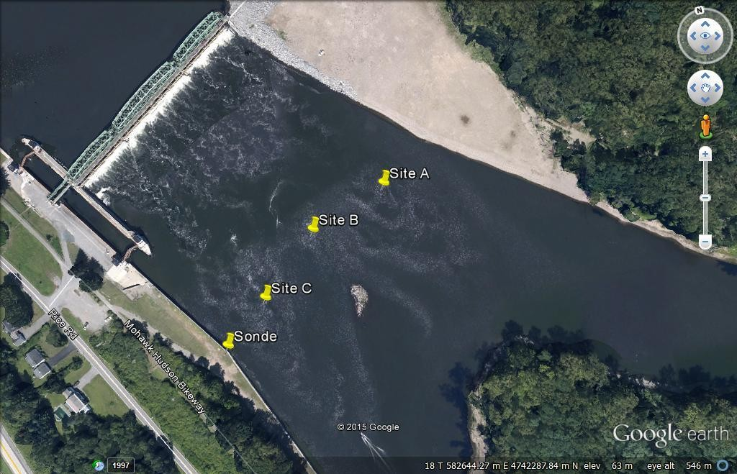

None of the solutes or dissolved oxygen showed significant variability across the channel or with depth. This is evident in a box-plot showing dissolved oxygen for the two dates broken out by shallow/deep samples (Fig. 2). There is clearly a seasonal difference, with April concentrations much higher due to cooler temperatures. Turbidity is typically the variable with the greatest variability both horizontally and vertically in prior HRECOS cross-channel sampling. At this Mohawk site there is very small variability on a given date although (as expected) there are much higher levels in April than June (Fig. 3)
Fig. 2: Box plot comparing dissolved oxygen for two dates at two depths (shallow (s) and deep (d)). Error bars are 1 Std Error.

12.8
12.6
12.4
12.2
12.0
11.8
11.6
11.4
11.2
11.0
10.8
10.6
10.4
10.2
10.0
9.8
9.6
June 2012
April 2014
s d s d
LOGS: IN
LOGS: OUT
Mean Mean±SE
Mean±1.96*SE
ODO mg/L

Fig. 3: Box plot of vertical variation in turbidity (NTU) for two dates at the Mohawk Lock 8 site.

80
70
60
50
40
30
June 2012
April 2014
20
10
0
s
d
s
d
LOGS: IN
LOGS: OUT
Mean Mean±SE Mean±1.96*SE
NTU

Overall, this site on the Mohawk is well-mixed undoubtedly because it is immediately below the spill way and the shore-mounted sonde will adequately characterize the channel at this point.

