|  |  |
| --- | --- |
| **Metadata: Piermont Pier Water Quality Station**  **C:\HRECOS\HRECOS_logo.small.TIFLocation:** Piermont, NY ([41.043, -73.896](https://maps.google.com/maps?q=41.043+N++73.896W&hl=en&sll=41.042899,-73.899214&sspn=0.013093,0.01929&t=h&gl=us&z=15) )  **Data collection periods:** 4/22/2008 – 10/29/2012 (Hurricane Sandy),  8/28/2013 – present.  **Parameters:** acidity, chlorophyll\*, water depth\*\*, dissolved oxygen,  salinity, specific conductance, turbidity, and water temperature  \*Chlorophyll measurements ended 12/12/2011 when it was decided that data from this instrument were not informative.  \*\*Use depth data with caution. As the depth sensor has not been surveyed to a known datum, depths are only relative to the water surface and may not be consistent throughout the history of this station due to sonde housing shifts and replacements. For more accurate water level data collected at Piermont Pier, access <https://waterdata.usgs.gov/ny/nwis/uv?site_no=01376269>. | |
| **Disclaimer:** HRECOS is a research project. No warranty—either express or implied—is made for any information presented by this program.  Piermont hydrological station is located on Piermont Pier, which is owned and operated by the village of Piermont. | |
| **Contacts**:  Brittney Flaten HRECOS Coordinator  NY State Dept. of Environmental Conservation  256 Norrie Point Way  Staatsburg, NY 12580  Phone: 845-889-4745 x117  Email: brittney.flaten [at] dec.ny.gov | Tim Kenna, Station Manager  Lamont-Doherty Earth Observatory  61 Route 9W  Palisades, NY 10964-8000  Email: tkenna [at] ldeo.columbia.edu |
| **Station details:**  The Piermont Pier sampling station, in Piermont NY (41° 2' 35.0226" N, 73° 53' 45.891" W), is situated on the end of a mile long pier stretching into the Hudson River. The pier is open to the public and regularly used for recreational purposes. It is located just north of the NERRS Piermont Marsh, a tidal salt marsh dominated by the invasive reed *Phragmites australis*, where approximately 30 MGD of secondarily treated sewage is discharged from Orangetown and Rockland County. The local tidal range varies between 3 and 5 feet and the river bottom is characterized by thick mud and rocks. A submersible YSI 6600 multi-probe sonde is deployed in a perforated PVC tube encasing mounted to the pier. The sensors sit ~3 feet below low tide. The installed sensors monitor dissolved oxygen, salinity, turbidity, water temperature, water depth\*\* and pH. This depth sensor has not been surveyed so we are not able to calculate water elevation; a USGS station, however, is located 10 feet to the north of our sensor and does record water elevation. Because the depth sensor is non-vented to the atmosphere, we adjust depth measurements for barometric pressure using the following equation: Corrected Depth = Depth + ((1013- Barometric Pressure) \* .0102). This correction is performed on all data since EST 9/23/2011 00:00:00. These corrections were made retroactively once per quarter until 4/18/2015 12:00 EST, when the correction was implemented as an automated calculation on the real-time data.  Equipment was upgraded to a YSI EXO2 sonde on 8/10/2023. | |
| **Summary of cross-channel analyses (see Appendix A for full report):**  Based on sampling on December 1, 2011, the river cross-section at this location showed greater variability in turbidity and conductivity across both distance and time than other HRECOS sites examined. Due to a dysfunctional sonde at the station, a comparison of longer term patterns was not possible. On the day of sampling there was a strong West to East gradient in turbidity which (if general) means the fixed HRECOS site will overestimate turbidity of the main channel at this location. There was no conclusive evidence of an effect of the wastewater outfall or Sparkill Creek on conditions observed at the fixed HRECOS site. The full report of this analysis is given as appendix A. | |
| **Special remarks / notes:**   * 01/06/2011: Sonde deployed from 1/6/2011 to 2/7/2011 failed during deployment. All data from this deployment was lost. * 02/07/2011: Dissolved oxygen probe failed for the duration of the 2/7/11 – 2/12/11 deployment. * 7/14/2011 – 10/23/2011: No data for this time period. * 9/23/2011 0:00: Started correcting depth for barometric pressure using the following equation: Corrected Depth = Depth + ((1013- Barometric Pressure) \* .0102) * 11/8/11 – 12/11/11: Unable to correct depth for barometric pressure because barometric pressure sensor had failed. * 10/30/2012: Sonde lost during Hurricane Sandy. * 8/28/2013: Station rebuilt and back online. * 4/18/2015 14:00: Automation of water depth correction for atmospheric pressure began * 1/1/2015 – 5/2/15 – Sonde deployment surpassed 3 months. All records flagged as suspicious. * 8/2/2015 – 10/13/15 – Sonde deployment surpassed 3 months. All records flagged as suspicious. * 1/27/2016 – After swap, sonde depth had major jump in baseline and all timestamps began recording “slow” in comparison to adjacent USGS stage readings. An automatic time adjustment (forward shift) seems to occur weekly. Suspected logger issues. For QAQC’d data, all raw data since this time has been replaced with internally logged sonde data. * 1/1/2016 to current – All data replaced with internally-logged sonde data, therefore depth data is not corrected for barometric pressure. * 9/1/2016: Sonde logging and telemetry system timing fixed. * 3/6/2017: Hydrological event preceding 3/6/2017 was an extreme freshwater flush with low temperatures. This type of environmental condition bring highly soluble cold water with high pH and Oxygen. * 3/23/2017: Sedimentation in conductivity flow cell may have impacted salinity readings. * 8/10/2023: YSI 6600-series sonde was replaced with YSI EXO2 series sonde. | |
| **Distribution terms:**  HRECOS requests that attribution be given whenever HRECOS material is reproduced and re-disseminated and the HRECOS Coordinator be notified prior to publications including any part of the data. Example citation: “Hudson River Environmental Conditions Observing System. 2012. Piermont Pier Hydrologic Station data. Accessed April 13th, 2016. <http://www.hrecos.org/>.” | |
| **Data Quality Assurance:**  Data collection and verification have been performed since December 2009 according to the HRECOS Quality Assurance Project Plan, which is available at [www.hrecos.org](http://www.hrecos.org) Prior to December, 2009, data were collected according to the manufacturer’s instructions only. Deployment dates and post calibration values were not recorded and data were not verified. See section on following pages for QAQC flag and comment code definitions. | |
| **QAQC Comment Code definitions:**  General Errors  [GIM] instrument malfunction  [GIT]   instrument recording error, recovered telemetry data  [GMC] no instrument deployed due to maintenance/calibration  [GPF]  power failure/low battery  [GQR]   rejected due to QAQC checks  [GSM] see metadata  [GIC] no instrument deployed due to ice  [GNF] deployment tube clogged/no flow  [GOW] out of water event  Sensor Errors  [SBO] blocked optic  [STF] catastrophic temperature sensor failure  [SCF] conductivity sensor failure  [SDF] depth port frozen  [SDP] DO membrane puncture  [SDO] DO suspect  [SIC] incorrect calibration/contaminated standard  [SNV] negative value  [SPC] post calibration out of range  [SSD] sensor drift  [SSM] sensor malfunction  [SOW] sensor out of water  [SSR] sensor removed (not deployed)  [STS] turbidity spike  [SWM] wiper malfunction/loss  Comments  (CAB) algal bloom  (CAF) acceptable calibration/accuracy error of sensor  (CAP) depth sensor in water, affected by atmospheric pressure  (CBF) biofouling  (CCU) cause unknown  (CDA) DO hypoxia < 28 percent saturation  (CDB) disturbed bottom  (CDF) data appear to fit conditions  (CFK) fish kill  (CIP) surface ice present at sample station  (CLT) low tide  (CMC) in field maintenance/cleaning  (CMD)     mud in probe guard  (CND)    new deployment begins  (CRE) significant rain event  (CSM) see metadata  (CTS) turbidity spike  (CVT) possible vandalism/tampering  (CWD) data collected at wrong depth  (CWE) significant weather event | |

|  |  |  |  |  |  |  |  |
| --- | --- | --- | --- | --- | --- | --- | --- |
| Parameter | Units | Sensor type | Model | Range | Accuracy | Resolution | Other |
| **Acidity** | Hydrogen ion concentration (pH) | Glass combination electrode | YSI 6589 Fast-response pH Sensor | 0 – 14 units | ±0.2 units | 0.01 units | NA |
| **Chlorophyll** | Micrograms per liter (µg/L) | Optical | YSI 6025 | 0 – 400 µg/L | NA | 0.1 µg/L | Detection limit: 0.1 µg/L |
| **Conductivity** | Microsiemens per cm (µS/cm) | Nickel electrode | YSI 6560 | 0 – 100 µS/cm | ±-0.5% + 0.001 µS/cm | 0.001 – 0.1 µS/cm (range dependent) | NA |
| **Dissolved oxygen** | Air saturation (%)  ¾¾¾¾  mg/L | Optical  ¾¾¾¾  Calculated | YSI 6150 ROX | 0 – 500%  ¾¾¾¾  0 – 50 mg/L | 0 – 200%: ±1%  200 – 500%: ±15%  ¾¾¾¾  0 – 20 mg/L: ±-0.1 mg/L or 1% (whichever is greater);  20 – 50 mg/L: ±-15% | 0.1%  ¾¾¾¾  0.01 mg/L | NA |
| **Turbidity** | Nephelometric Turbidity Units (NTU) | Optical | YSI 6136 | 0 – 1000 NTU | ±2% or 0.3 NTU (whichever is greater) | 0.1 NTU | NA |
| **Salinity** | Practical salinity units | Calculated from conductivity and temperature | |  |  |  | NA |
| **Water level** | Meters (m) | Stainless steel strain gauge | YSI 6600 (integral) | 0 to 30 ft (9.1 m) | 0-10 ft: +/- 0.01 ft (0.003 m); 10-30 ft: +/- 0.06 ft (0.018 m) | 0.001 ft (0.001 m) | NA |
| **Water temperature** | Celsius (°C) | Thermistor | YSI 6560 | -5 – 45 °C | ±0.15 °C | 0.01 °C | NA |

**Table 1. YSI 6600-series sonde sensor specifications. Equipment was upgraded on 8/10/2023.**

|  |  |  |  |  |  |  |  |
| --- | --- | --- | --- | --- | --- | --- | --- |
| Parameter | Units | Sensor type | Model | Range | Accuracy | Resolution | Other |
| **Acidity** | Hydrogen ion concentration (pH) | Glass combination electrode | 599702 | 0 – 14 units | ±0.1 pH units within ±10°C  of calibration temperature;  ±0.2 pH units for entire temp range | 0.01 units | N/A |
| **Conductivity** | microSiemens per cm (µS/cm) | 4-electrode nickel | 599870-01 | 0 – 200 µS/cm | 0-100 µS/cm: ±0.5% of  reading or 0.001 µS/cm,  whichever is greater;  100-200 µS/cm: ±1% of  reading | 0.0001 to 0.01 µS/cm  range-dependent | N/A |
| **Dissolved oxygen** | Air saturation (%)  ¾¾¾¾  mg/L | Optical, luminescence lifetime ¾¾¾¾  Calculated | 599100-01 | 0 – 500%  ¾¾¾¾  0 – 50 mg/L | 0 – 200%: ±1%  200 – 500%: ±5%  ¾¾¾¾  0 – 20 mg/L: ±0.1 mg/L or 1% (whichever is greater);  20 – 50 mg/L: ±-5% | 0.1%  ¾¾¾¾  0.01 mg/L | N/A |
| **Turbidity** | Formazin Nephelometric Units (FNU) | Optical, 90° scatter | 599101-01 | 0 – 4000 FNU | 0-999 FNU: 0.3 FNU or  ±2% of reading, whichever is greater; 1000-4000 FNU: ±5% of reading | 0-999 FNU: 0.01 FNU  1000-4000 FNU: 0.1 FNU | N/A |
| **Water temperature** | Celsius (°C) | Thermistor | 599870-01 | -5 to +50°C | -5 to 35°C: ±0.01°C  35 to 50°C: ±0.05°C | 0.001°C | N/A |
| **Salinity** | Practical salinity units | Calculated from conductivity and temperature | 599870-01 |  |  |  |  |
| **Water level** | Meters | Pressure transducer | Integrated in sonde (YSI EXO2) | 0 – 10 m | 0 – 15 ft: ±0.01 ft (0.003 m);  15 – 35 ft: ±0.065%;  35 – 50 ft (0.006 m) | Max. traceable rate: 3 ft/minute | Non-vented depth sensor |

**Table 2. YSI EXO2 sensor specifications. Beginning 8/10/2023.**

**Appendix A:**

**Final Report**

**Characterizing cross-channel variability at the Piermont HRECOS site.**

**Prepared by:**

**Stuart Findlay**

**Cary Institute of Ecosystem Studies**

**Millbrook, NY**

**Transmitted to Alene Onion, HRECOS Coordinator on December 30, 2011**

On December 1, 2011 we conducted a survey of cross-channel variability adjacent to the Piermont Pier HRECOS deployment. The HRECOS sonde is located in a pipe on the southern side of the pier in approximately 4 m water depth. Due to concern about the condition of the existing HRECOS sonde we attached a newly-calibrated sonde at the same location as the existing sonde. This sonde was programmed to log every 5 minutes for the interval of our field sampling. To assess how well this location represents conditions across the channel we conducted two sampling transects each including three locations (Fig. 1) where we conducted vertical sampling. Following established procedures we towed a YSI Water Quality sonde approximately 1 m sub-surface across the transect with logging set for 30 sec intervals. Due to the width of the Hudson at this location it required nearly an hour to traverse the channel. Sampling occurred between Noon and 3 PM (EST) during a flooding tide since the main concern at this site was the possible influence of a wastewater outfall and the Sparkill Creek both located south of the Pier. At Locations A,B,C along the transect the sonde and a sampling tube connected to a peristaltic pump were lowered to 1 and 5 m (and 10 m in the navigation channel (Site C)) to collect observations and an actual water sample from these depths.

All sonde calibration and suspended matter determinations followed established procedures.

**Fig. 1: Google Earth image of Piermont reach of the Hudson River showing approximate locations of the fixed sonde, sampling transect and sites A-C.**

**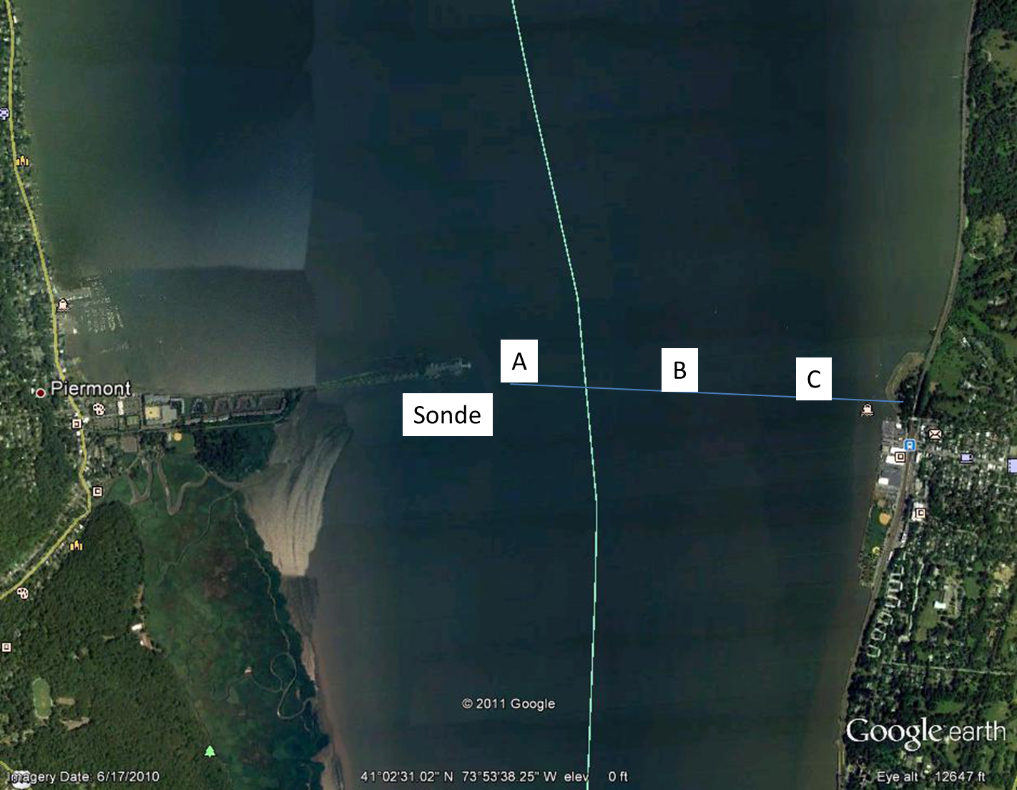**

Both conductivity and turbidity records at the Pier showed increases during the three hour period of flooding tide. Conductivity is likely simply due to an upriver flow of higher salinity water. The turbidity increase could be due to either local resuspension or upriver movement of a water mass with higher turbidity.

**Fig. 2: Changes in conductivity and turbidity recorded by the temporary sonde attached to the pier during the 3 hour transect sampling interval.**

Sampling across the channel revealed large and distinct differences in turbidity with highest values on the west side of the channel, decreasing towards the east during both traverses (Fig. 3). Higher values occurring at ~ 80 and 120 minutes represent times the sonde was lowered for vertical profiles (see below).Samples of suspended matter showed distinct differences among locations with values at Location “A” nearly two-fold higher than Location “C” in the navigation channel (Fig. 4).

**Fig. 3: Cross-channel variation in turbidity as recorded by the towed YSI Sonde. The X-axis is in minutes since 11 AM for ease of comparison with the fixed (pier) sonde. Two traverses were carried out, the first lasting from roughly 70 to 130 minutes past 11AM and the second from 140 to 210 minutes and each was from West to East.**

First traverse

Second traverse

**Fig. 4: Variation in suspended matter in shallow water (depth = 1 m) samples collected at locations A-C (West to East) across the transect.**



Samples for suspended matter collected along vertical profiles showed higher values at depths 5 and 10 (Fig. 5) although statistical analysis was equivocal since only “Location “C” was deep enough to allow sampling at 10 m.

**Fig. 5: Depth variation in suspended matter. Locations “A & B” were sampled at 1 and 5 m while Location “C” was sampled at 1,5 and 10 m.**

There were slight West to East gradients in conductivity with a range of less than 0.1 mS (not shown) but little evidence of strong vertical variation in conductivity. Dissolved oxygen and pH showed no variation across the transects. The average dissolved oxygen was 11.2 mg/L with a standard deviation of only 0.1 mg/L. Mean pH was 7.9 pH units.

**Fig. 6: Variation in conductivity across sampling depth showing no consistent stratification (higher conductivity at depth) during this three hour period.**

**Conclusions**

1. On the date of sampling the Piermont cross-section showed greater variability in turbidity and conductivity across both distance and time than other HRECOS sites examined.
2. Lack of a functional fixed sonde makes comparison of the particular sampling dates to longer term patterns impossible.
3. On the day of sampling there was a strong West to East gradient in turbidity which (if general) means the fixed HRECOS site will overestimate turbidity of the main channel at this location.
4. There was no conclusive evidence of an effect of the wastewater outfall or Sparkill Creek on conditions observed at the fixed HRECOS site.